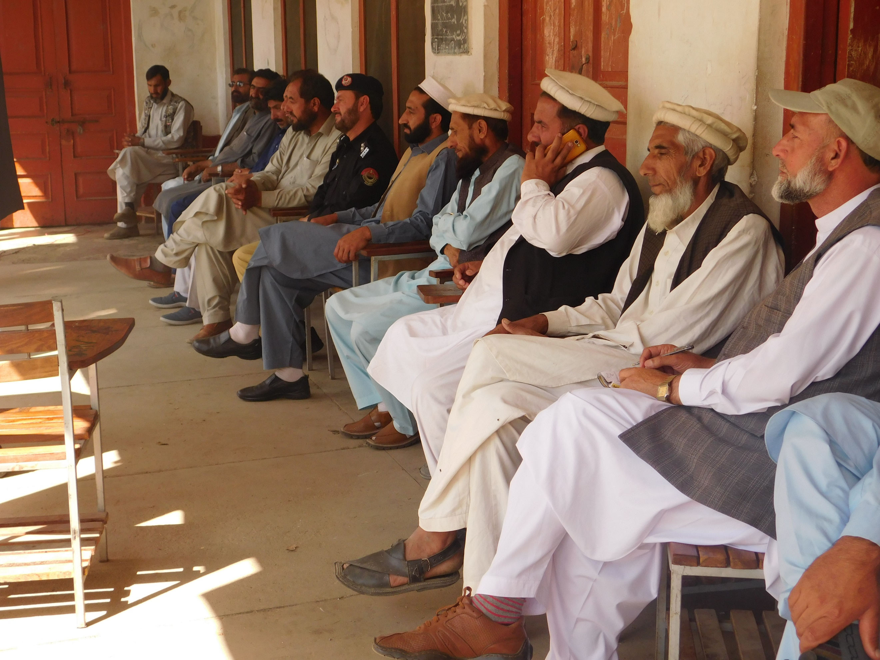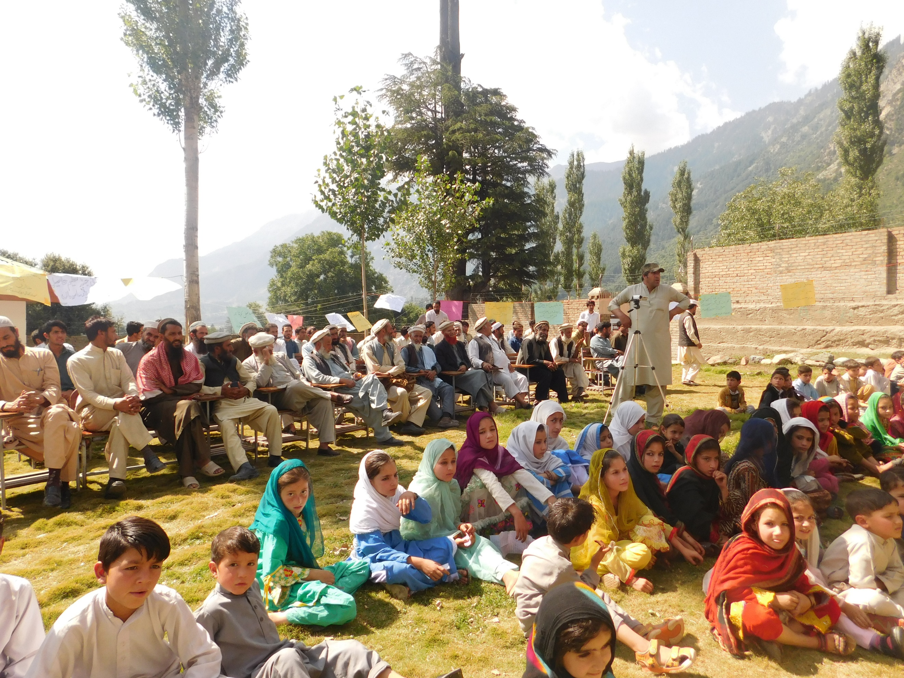  International Literacy Day  By GCDP and FLI | Abstract  International Literacy Day was observed by GCDP in cooperation of FLI at GHS Ashoran Kalam Valley, Ex Tehsil Nazim Habibiullah Saqib, Ex Tehsil Youth Councilor Nasirullah Ansari, Ex Vice President UC Kalam Malak Amir Said, Elders from Kalam, Govt Officials and Intellectuals participated in this event. They share their views and suggestion on Promoting Literacy in Swat Kohistan and also praised the work of GCDP and FLI for promoting MTB MLE Education in Swat Kohistan. The event was very fruitful and great outcomes, which are explained in details in outcomes section  Hayat Mohammad  Media and Communication Officer

Intro

A ceremony was held on the occasion of International Literacy Day at GHS Village Ashoran Kalam. GCDP (Gawri Community Development Programme) celebrate this Day with great pump and show for several Years to make awareness regarding lack of literacy ratio in Swat Kohistan. 2 Years before GCDP have signed an MOU with FLI (Forum for Language Initiatives Islamabad) to establish more MLE (Multi Lingual Education) schools in Swat Kohistan. According to this MOU GCDP celebrate Int Literacy Day in collaboration with FLI since last two Years.
Last Year this event was held in Bafar Valley Kalam Swat, which had fruitful outcomes and the local community was highly motivated toward increasing the ratio of Literacy Rate in the Area.
This Year GCDP and FLI decided to celebrate this Day at GHS in Ashoran Village Kalam Swat, where the Literacy Rate is too poor specially in Girls. It may be also the the great outcome of the previous event, much more people from every walk of Life participated in this event as compared to the last.
Govt officials, political workers, school teachers, students, social activists and intellectuals from different villages participated in this event.
The who participated in this event were Ex Tehsil Nazim Habibullah Saqib, Ex Tehsil Youth Councilor Nasirullah Ansari, Ex Vice Nazim VC Matiltan Engineer Saeed, Ex Vice Nazim VC Kalam Malak Amir Said, Ex District Councilor Malak Hassan Zeb, Jirga Head Malak Ghazan Khan, SHO Police Station Kalam Sarbaz Khan and some other Political Workers and Social Activists.
The Guests shared their thoughts, views, experience and suggestions on How to Promote Literacy Rate in the Marginalized Community of Swat Kohistan.
Mr. Qari Sadiq Amin recited some verses of the Holy Quraan and the programme started formally.
The programme was staged by Mohammad Nazir (Community Mobilizer FLI)
Mr Shamshi Khan (PRO GCDP) Shortly briefed the aims and objectives of the event and also briefed on the Struggle of GCDP and FLI in Promoting Literacy in the villages of Swat Kohistan.
After Briefing by Mr. Shamshi Khan one student of GMLE School Yasira offered Gawri Poem in her sweet voice, which sore the blood of the participants. Another student Shabnam offered the Naat in Urdu.
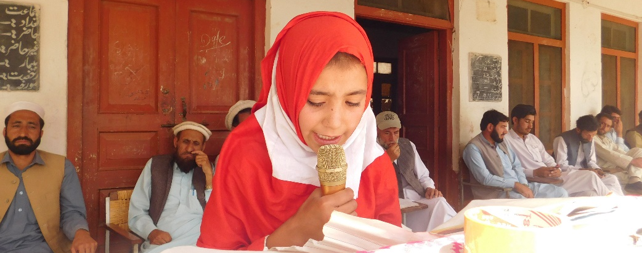
The addresses of the guests to the participants were as below
Mr. Abdul Wadood (Supervisor Gawri MLE Schools)
He shed the light on current Literacy Ratio and hurdles to Literacy in Swat Kohistan. He shared his experience as a Supervisor of MLE Schools. MLE Schools are playing key role in promoting the Literacy in deprived, backward and mountainous indigenous community of Swat Kohistan, he said. Seasonal Migration is badly affecting the studies of school children, he added. he suggested some Tricks to overcome the migration issue.
Pashum Khan (Tehsil Secretary Bahrain Swat)
He quoted some verses of The Holy Quraan about the need of Education and also told some Hadiths about the Right to Education for both men and women.
He said that every child has the right to get Education, so if we deprive them from education, it means that we are arrogating their Rights.
As a citizen it is the responsibility of every individual to take play their tole for improving the Literacy Rate in our backward area. So, we need to struggle for the betterment education and make Study Environment in our Community.
Malak Ghazan Khan (Local Jirga Head)
His speech was about the need of Education in Modern Era.
He said that without Education no one can go ahead and take part in prosperity of the community, He By quoting a Hadith he said, seek knowledge even you have to go to China.
Education is most important for New Generation and their welfare and development, he said.
Nasirullah Ansari (Ex Tehsil Youth Councilor Bahrain)
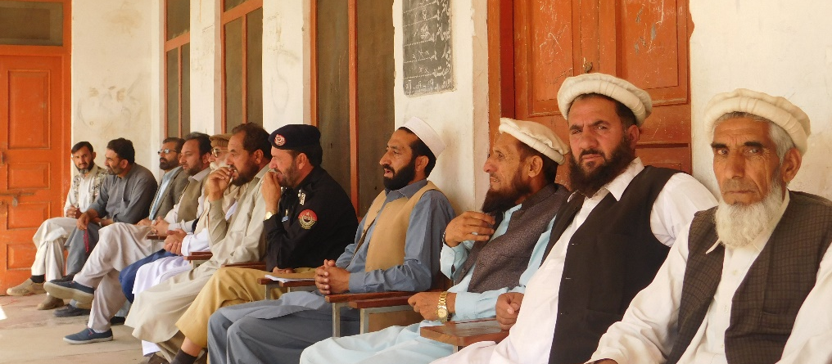
He explained that how to make our Local Traditional Jirga’s helpful for the promotion of Literacy and Education in the area.
He said that this is the big fact that our Local Jirga have as power as it can solve the High Level Criminal cases and clashes among the People, but it is also a big fact that our Jirga never took interest to solve Education Issues, so we should call Local Jirga for discussing the alarming situation of Education in Swat Kohistan.
He said that Education is the basic Foundation for development, we have got much experience in Tehsil assembly that how Education is must for Developmental Work in the Area.

Malak Amir Said (Ex Vice Nazim UC Kalam)
He said that we can fairly feel that to overcome the other needs of our Community we should keep Education in priority.
He offered tribute to GCDP and FLI for their great efforts on promoting Literacy in Swat Kohistan.
Better is to seek knowledge and transfer it to other, He said.
He also agreed that the Migration is a big hurdle for our children to complete their school studies. We must think about this issue and take it seriously and find the ways to overcome this issue. So, our children can meet the Syllabus they taught in the schools.
Mr. Faqir Mohammad (Primary School Teacher)
He appreciated the GMLE Schools and said that their students are much better than other govt and private schools. I have personally compared MLE School Students with my own school.
He pointed out the big achievement of GCDP and said that community have full confidence on its Schools, it is why MLE Schools teachers of agree to teach the MLE Students in very low salary and take part in Spreading Education in their Villages.
Fazal Wahab Butto (President of Political Party at Kalam)
He paid tribute to GCDP and FLI for their great struggle for promoting Education in Swat kohistan. He suggested that Local Govt also should take part in these kinds of Educational Programmes.
Engineer Saeed (Ex Vice Nazim VC Ushu Matiltan)
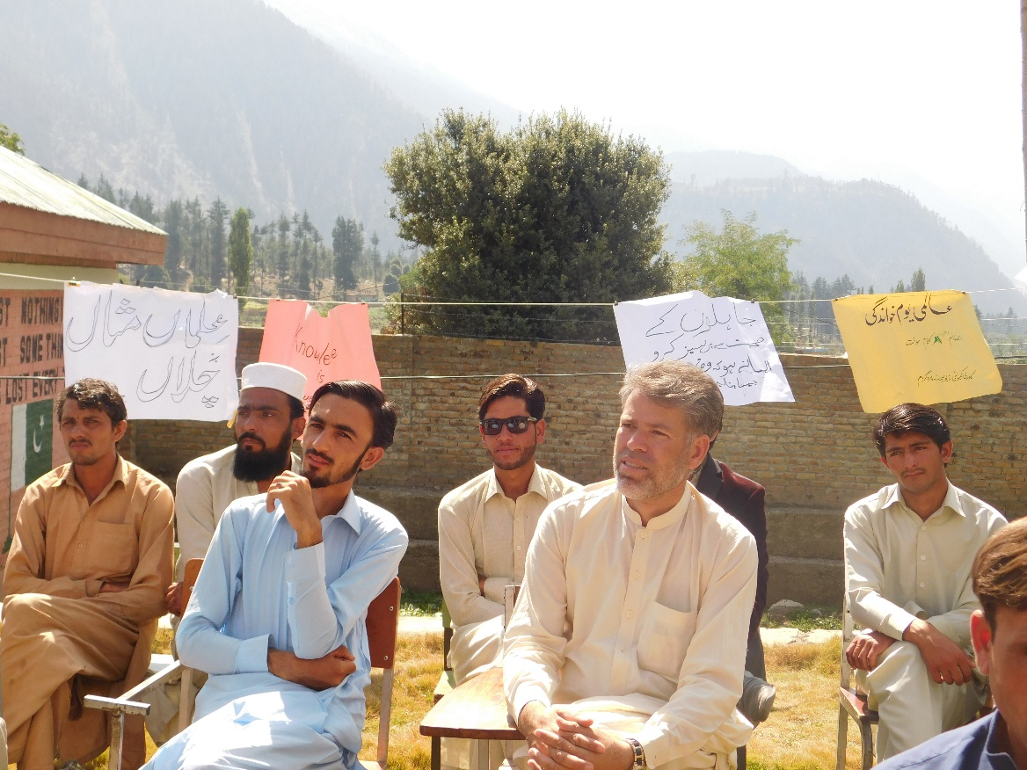
He said that I would say in short that we cannot promote developmental sector without Quality Education and the UNESCO has proved that the Quality Education can be got in the Mother tongue.
He said that I will support GCDP in every platform, every situation and every occasion to promote the Literacy in Swat Kohsitan.

Sarbaz Khan (SHO Police Station Kalam)
He said that I am performing my duty here in Kalam for one Year, I have personally realized that the main issue of the students is Sessional Migration in Winter and Migration is the main cause of poverty in the area. The locals should find the way to overcome the poverty first, then our locals need no migration to support their family financially and the students may complete their studies and education ratio will be increased.
Parents should have sensibility to send their children to Schools.
Malak Hassan Zeb (Ex District Councilor VC Kalam)
He said that government and political leaders of the area should take actions for the improvement of Education and Local Social Activists, Intellectuals and Youngsters should take part mutually to improve the Quality of Education.
Habibullah Saqib (Ex Tehsil President Bahrain Swat
He praised the standard of MLE Schools of GCDP and said that MLE Schools have their unique standard to give quality education for Backward area students, which have Unique Culture, Mother Tongue and Life Style, GCDP is providing the quality education according to their Cultural, Lingual and environmental context.
He said that I will fully support GCDP and it is my own responsibility as a politician. We should not wait furthermore and jointly stand for the betterment of Education in our Community.
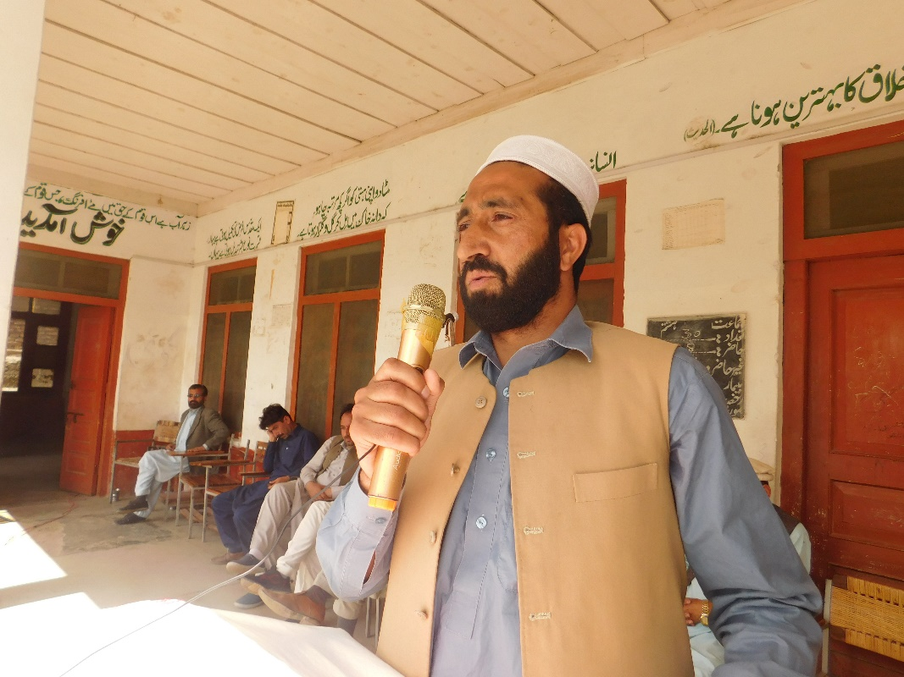

Students’ Performance and Awards
At the end GMLE School students shown their talents by performing speech, Naat, Poems and Stories.
The Guests distributed awards among the best performers and encouraged them.
Awards were distributed by Malak Amir Said, Zamin Akhtar, Engineer Saeed, Fazal Wahab Bhutto, Nasirullah Ansari, Malak Hassan Zeb and Habibullah Saqib
The Programme Windup
Mr. Muhammad Dinn (President SMC Committee Matiltan Ka
lam) winded up the programme by praying
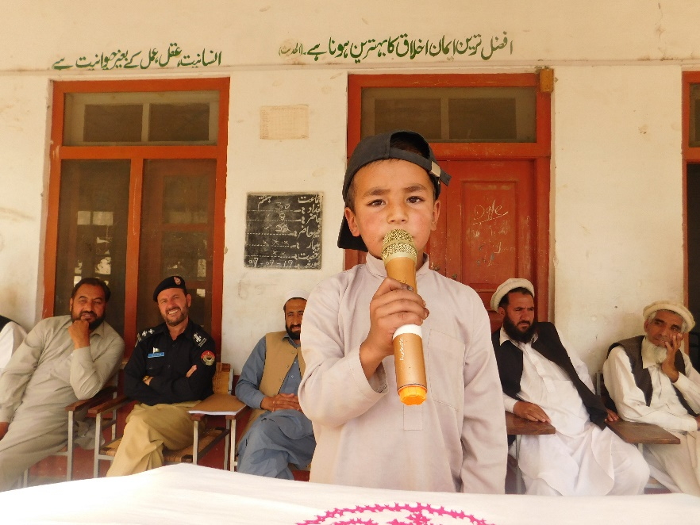
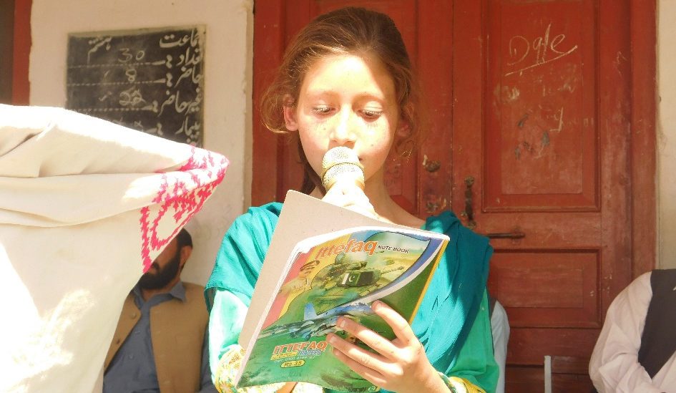
The Outcomes

The Officials and local elders were too motivated that they heartily felt the need of practically measures for the betterment of Literacy in the area.
They established a core committee, which will communicate with the elders of Kalam and will hold a Jirga on Literacy issue in Swat Kohistan.
Along with the MLE Schools Children the govt school children were also impressed by the speech, tales and poems in Gawri Language.
Later after the event one of the Jirga Elder Mr. Muhibullah Khan met with the Leadership Team of GCDP to take necessary actions against the lack of Teaching Staff in GHSS Kalam.
The Private School Principal Mr. Zamin Akhtar who was the guest in the Programme hold a meeting with GCDP Officials to cooperate with GCDP for making awareness about the Literacy.
Coverage in Newspapers

